**CloudFormation Template Best Practices**

* Avoid Hardcoding as much as possible
* <https://github.com/asquarezone/awsadministration/commit/e59596188bdcbe5ae0d7aeb86b9ef1eb3cb45167> for the changes done to avoid hardcoding
* Image id => This is tricky as it changes for every region. So in this case we would like to use ubuntu20 ami. The cli query to get the ami id of ubunutu 20.04 in any region

aws ec2 describe-images --filters "Name=name,Values=ubuntu/images/hvm-ssd/ubuntu-focal-20.04-amd64-server-20211129" --region <region-code> --query "Images[0].ImageId"

* To accomodate region wise settings we can use Mappings <https://docs.aws.amazon.com/AWSCloudFormation/latest/UserGuide/mappings-section-structure.html>
* To use the map value in resources <https://docs.aws.amazon.com/AWSCloudFormation/latest/UserGuide/intrinsic-function-reference-findinmap.html>
* [Refer Here](https://github.com/asquarezone/awsadministration/commit/49273a01d55942feea21db0c8d95e4210519577a) for the changes with mappings
* Now lets add required outputs for the template <https://docs.aws.amazon.com/AWSCloudFormation/latest/UserGuide/outputs-section-structure.html> for the documentation of outputs
* To get attributes use Fn::GetAtt <https://docs.aws.amazon.com/AWSCloudFormation/latest/UserGuide/intrinsic-function-reference-getatt.html>
* After adding some outputs to the template and updating the stack. <https://github.com/asquarezone/awsadministration/commit/02db6ce9cb9928f2336027c6226254cc723dbdd2> for the changes done  
  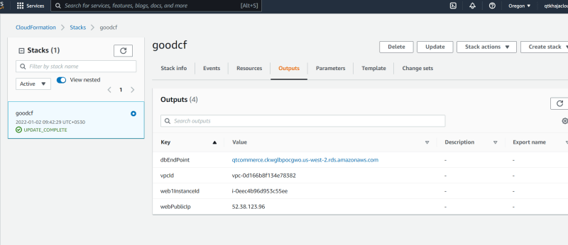
* Note Stacksets can be used to create stacks in multiple regions.  
  